**AI-Driven Exploration and Prediction of Company Registration Trends with Registrar of Companies**

**Design thinking:**

Design Thinking is a creative problem-solving approach that can be applied to designing an AI-driven exploration and prediction system for company registration trends. Here's a simplified step-by-step process:

**1. Empathize:**

* Understand the needs of users and stakeholders, such as business analysts, government officials, and entrepreneurs.
* Conduct interviews and surveys to gather insights on their pain points, goals, and expectations related to company registration data.

**2. Define:**

* Clearly define the problem statement and project goals. For example, "Create an AI system to analyze company registration data and predict emerging trends for the Company Registrar's office."
* Identify key success metrics, like prediction accuracy or user satisfaction.

**3. Ideate**

* Brainstorm potential AI-driven solutions and features that can address the defined problem. Consider features like trend analysis, anomaly detection, and data visualization.
* Encourage creativity by involving cross-functional teams.

**4. Prototype:**

* Develop a prototype of the AI system. This might involve creating wireframes or mockups of the user interface and designing the architecture of the AI model.
* Focus on creating a user-friendly interface for accessing and interacting with the AI predictions.

**5. Test:**

* Collect feedback from potential users through usability testing of the prototype.
* Refine the system based on user feedback and make necessary adjustments to improve its usability and functionality.

**6. Implement:**

* Develop the AI model and integrate it with the user interface and data sources.
* Ensure the system is scalable, secure, and compliant with relevant data privacy regulations.

**7. Monitor:**

* Implement monitoring tools to continuously track the performance of the AI model and system.
* Regularly update the AI model with new data to improve prediction accuracy.

**8. Iterate:**

* Continuously gather user feedback and iterate on the system to enhance its capabilities and address changing user needs.
* Stay up-to-date with the latest AI and machine learning advancements to incorporate improvements.

**9. Deploy:**

* Launch the AI-driven exploration and prediction system for company registration trends.
* Provide training and support for users to ensure they can effectively utilize the system.

**10. Evaluate:**

* Periodically assess the system's impact on improving the efficiency of company registration processes and its ability to predict trends accurately.
* Adjust the system's features and functionality as needed based on ongoing evaluations.

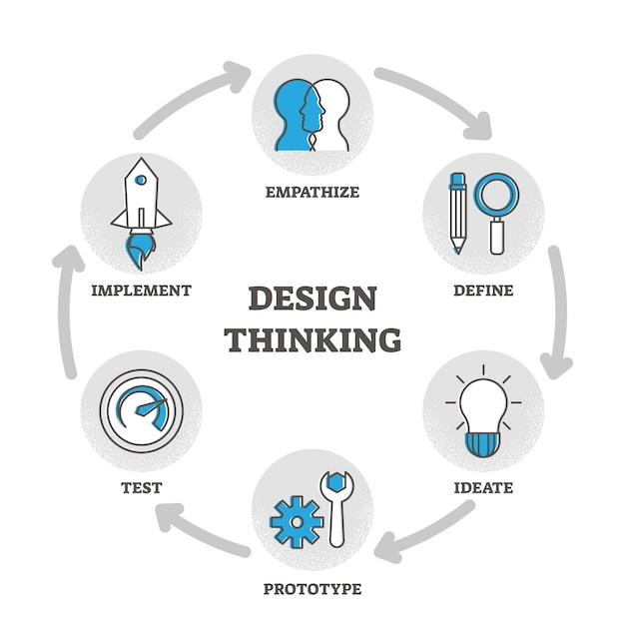

**|Innovative Ideas about an AI-Driven Exploration and Prediction of Registration Trends with Registrar of Companies:**

**1. Natural Language Processing (NLP) for Data Extraction:** Develop NLP algorithms that can extract relevant information from unstructured textual data, such as news articles, press releases, and regulatory filings, to identify trends in company registration.

**2. Predictive Analytics Models**: Build predictive models that use historical data from the company registrar to forecast future registration trends. Machine learning techniques, such as time series analysis and regression, can be employed for this purpose.

**3. Graph Database for Relationship Analysis:** Utilize graph databases to map relationships between companies, shareholders, and directors. This can help identify patterns in company registration and ownership structures.

**4. Sentiment Analysis:** Implement sentiment analysis on news and social media data to gauge public sentiment and its potential impact on company registration trends. This can be particularly useful for investors assessing market sentiment.

**5. Geospatial Analysis**: Incorporate geospatial data to analyze regional variations in company registration trends. This can provide insights into economic development and investment opportunities in specific areas.

**6. Fraud Detection and Prevention:** Develop AI algorithms that can detect fraudulent company registrations by analyzing registration patterns and flagging suspicious activities for further investigation.

**7. Blockchain for Transparency:** Explore the use of blockchain technology to create a transparent and immutable record of company registrations. This can reduce fraudulent activities and ensure data integrity.

**8. Predictive Compliance Monitoring:** Use AI to monitor compliance with registration regulations and predict potential non-compliance issues. This can assist regulatory authorities in proactively addressing compliance issues.

**9. Real-time Data Integration:** Implement real-time data integration with the company registrar's database to provide up-to-date insights into registration trends and changes.

**10. Interactive Data Visualization:** Create user-friendly dashboards and visualization tools that allow users to explore company registration trends interactively. These tools should provide insights through graphs, charts, and maps.

**11. Ethical AI and Privacy:** Ensure that AI-driven exploration and prediction systems adhere to ethical guidelines and respect privacy regulations, especially when dealing with sensitive company information.

**12. Collaboration with Government Agencies:** Collaborate with government agencies responsible for company registration to access and analyze authoritative data sources, enhancing the accuracy of predictions.

**13. Continuous Learning and Improvement:** Implement a feedback loop to continuously train and improve AI models as new data becomes available and as registration trends evolve.